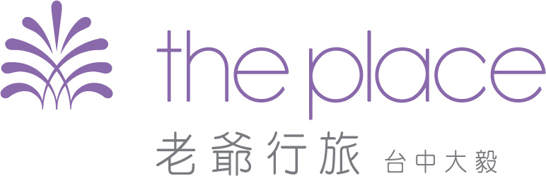

Reservation Request Form
2024 ICGET-TW
「2024綠色電化學科技國際學術研討會暨2024年台灣電化學學會年會」」專用訂房單
(僅適用於2024/11/6-2024/11/10)
COR. Code ：C00847
COR.：國立中興大學

房客姓名  Guest Name |  | 國籍  Nationality
Email
連絡電話  Telephone |  | 傳真  Fax

抵達日期  Arrival Date |  | 離開日期  Departure Date

房型  Room Type | 坪數  Size | 間數  No. of Rooms | 房價/晚 |  | 備註  Remarks
房型  Room Type | 坪數  Size | 間數  No. of Rooms | 11/6~11/10  平日優惠價 | 11/9(Sat.)  假日優惠價 | 備註  Remarks
旅人客房  SMART ROOM | 8坪 |  | $2,600 | $3,400 | - Breakfast Included
綠光客房  TREAT ROOM | 8坪 |  | $2,900 | $3,700 | 2 Breakfasts Included
風格客房  Mix Suite | 12坪 |  | $3,500 | $4,300 | - Breakfast Included
風格客房  Mix Suite | 12坪 |  | $3,800 | $4,600 | - Breakfasts Included
Notes:
- Check-in time 4:00 P.M. and Check-out time 11:00 A.M.
- Please fill in this application and mail to The Place Taichung.
- All reservation have to according this application。(email: tc.rsvn.s@tc.hotelroyal.com.tw )
- Please don't hesitate to contact us if you need any further information. Thank you!
- 以收到飯店訂房確認書為完成訂房，謝謝。

To guarantee your reservation, kindly provide your credit card details below ：
持卡人  Card Holder |  | 卡別  Credit Card Type | □ VISA □ MASTER □ JCB  □ American Express □ 銀聯卡
卡號  Credit Card No. |  | 有效日期  Valid Dates
持卡人簽名  Card Holder  Signature | (請與信用卡背面簽名一致)
Address:403台中市西區英才路601號
No. 601, Yingcai Road, West District, Taichung City 403, Taiwan.
Reservation Number: +886-4-2376-6732

